# New Zealand Tours designed to enrich your holiday experience

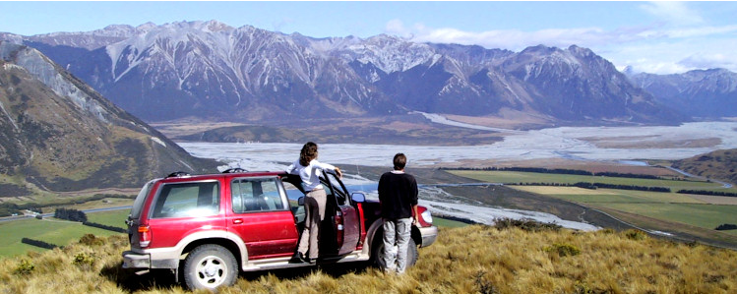

Our aim has been to position ourselves apart from the mainstream and surprise the market again and again with innovative ideas and new concepts. As you browse through our Website you will find evidence of the product variety and the fresh approach we are taking to create an enriching holiday experience for our clients.

We have positioned ourselves as the market leader for nationwide 4x4 touring, in the self-drive tours as well as in the escorted group tours segment.

Our Hiking, Trekking Bike, Campervan, Motorhome and Self-Fly "soft adventure" packages are legendary! If you were looking for an experience, which not only shows you the known highlights of New Zealand but also delivers an insight into life away from the normal tourist tracks, you would be well served by choosing one of our tours!

**Self Drive Rental Car Tour - with a difference**

**From the far North to the deep South- The whole of New Zealand!**

* 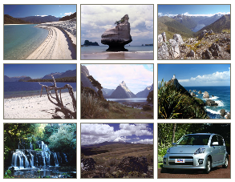20 / 24 days from Auckland via Stewart Island to Christchurch
* Experience New Zealand as never before. From top to bottom, you'll see the country in its entirety including the most important National Parks.
* Apart from the well known regions also explore less frequented parts of the country such as Mount Taranaki (Egmont National Park), Stewart Island and the Catlins on the way to Dunedin.
* Beginning in either Christchurch or Auckland your holiday can also be shortened to twenty days by cutting out the northernmost stretch of the journey.

# Hiking Tours



Over the years we have conducted countless guided Hiking Tours for groups and we can therefore draw on a lot of experience.

Our tour guides know New Zealand extremely well and like to share their love for New Zealand´s pristine environment with our customers.

We are able to custom design Hiking Tours for groups of every size, starting from small minibus tours to larger coach tours.

If you are looking for a hiking arrangement for your group please let us know and we will gladly work out a suitable itinerary and present you with a quotation.

**Self Drive Motorhome Safari**

**Motorhome Freewheeler option:** Explore New Zealand independently.You can choose your overnight and daily stays as you wish. This option gives you maximum flexibility.

Campgrounds: Reservations for space are highly recommended during the New Zealand summer holidays in January.

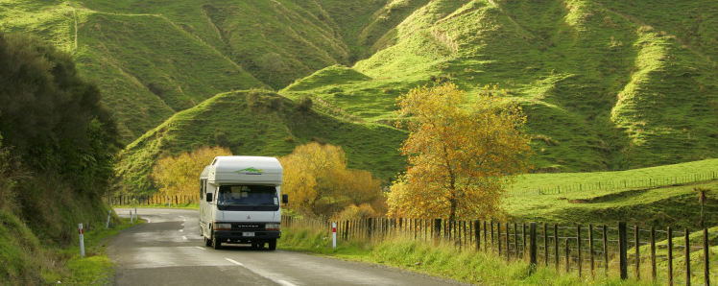

**Motorhome Inclusive option:** All campgrounds in holiday parks are included in the booking!

* The routes have been especially picked for you and some of them take you into remote regions.
* Apart from the remote countryside you will also visit many of the well known highlights of New Zealand.
* Detailed route - and driving instructions will enable you to reach your daily destination without any difficulties.
* Departures available daily.
* Due to weather conditions the itinerary can change at short notice.
* 2 to 6 berth Motorhome options including mountain bike carrier (optional) for two bikes. The tour can be booked including mountain bikes!

**Drive and Bike Tour**

**By 4x4 or normal Rental Car, inclusive of Trekking Bikes, pre-booked accommodation and suggestions for local bike excursions!**

**22 Days North and South Island**

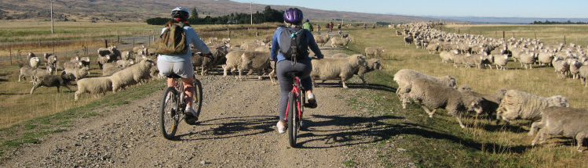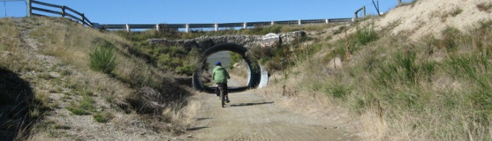

* Our 22-Day Drive and Bike Tour is the perfect combination of comfort, independence and physical activity!
* We look after the tour organisation and you enjoy as much physical activity as you opt for - you are in charge of this part of your holiday!
* In your supplied tour manual you are supported by detailed driving instructions, which help you to reach your driving destination and accommodation, from where you will then be able to start your bike tours if you so desire.
* The tour has been designed for clients of all levels of fitness and we offer options for beginners as well as for experienced bikers. There are always other options available, should you not be in the mood for cycling.
* Experience New Zealand's incredible and varied landscape - see the majority of the well known "highlights" but also get out there amongst it on a bike!

**NZ Sky Safari**

**New Zealand has become one of the world's preferred tourist destinations for those desiring a breathtaking holiday experience.**

Going one better, Rest New Zealand Tours and its joint venture aviation partners have developed a unique tour package called "The New Zealand Sky Safari" just for those tourists with a yearning for a personalised aviation adventure.

Flying from one highlight to the next within New Zealand's diverse landscape and exploring the exciting ground activities on the way are the ingredients of this memorable fun holiday.

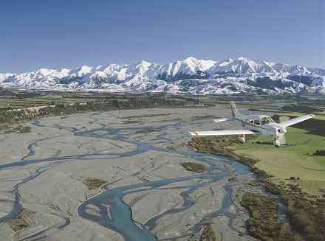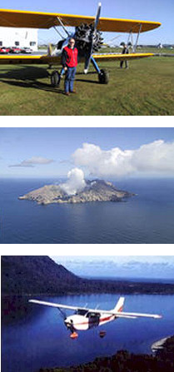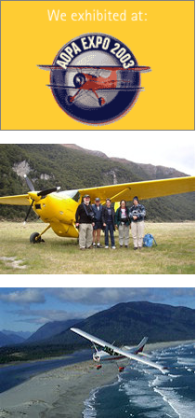

Use html code to lay out a web page that looks like the sample.

Specify your own font styles, sizes and colours.

Don't worry about line breaks – the browser will take care of them depending on the width of the browser window.

Use Photoshop to prepare the images for your web page:

* Resize them where needed, so that they appear at the correct size on your page without forcing a resize through the coding.
* Images should be in jpg or png format and compressed to as small a file size as possible without losing too much quality. This will speed up the loading of your web page.